PUNE DISTRICT EDUCATION ASSOCIATION’S
SETH GOVIND RAGHUNATH SABLE COLLEGE OF PHARMACY
SASWAD, DIST-PUNE
Report on Elocution Competition
Organized on the occasion of birthday celebration of Hon. Shri. Ajit Dada Pawar,
Ex-Deputy Chief Minister of Maharashtra and
President of Pune District Education Association on 26th July 2022
Elocution refers to one’s capacity of communicating with others, with the use of exact speech and gestures. Keeping this in mind Pune District Education Association’s Seth Govind Raghunath Sable College of Pharmacy, Saswad has organized Elocution Competition on 26th July 2022 on the occasion of birthday celebration of Hon. Shri. Ajit Dada Pawar, Ex-Deputy Chief Minister of Maharashtra and President of Pune District Education Association in Classroom No. 4 (Smart Class Room) at 10.30 am. The program was started with a welcome speech by Mr. Amol Kale, Program coordinator which was followed by inauguration session. The participants of competition were evaluated by Dr. Smita Pawar and Mrs. Vaishali Takawale.
The participants won the hearts of the judges and the audiences with their confidence, expression, and talent and made the event really memorable. More than 10 students from different classes participated in the event. The topics for elocution competition were:
- Ajitdada Pawar: Progressive and Visionary Leadership
- Beti Bachao Beti Padhao
The result of the same is as follows:
Sr. No | Level | Name of the student | Class | Rank
1 | UG | Ms. Pandit Pratiksha Dnyandeo | Final Year B. Pharmacy | First
2 |  | Ms. Yadav Sakshi Munnasingh | Second Year B. Pharmacy | Second
3 | Diploma | Ms. Gaikwad Rima Anil | Second Year D. Pharmacy | First
4 |  | Ms. Yadav Sujata Santosh | Second Year D. Pharmacy | Second
All the faculty, supporting staff members and students participated enthusiastically in the program. The session was culminated by vote of thanks by Mr. Sanjay Rokade store keeper. The program was compered by Ms. Payal Borawake, Lecturer. The program was attended by total 98 students and staff. (72 students and 26 staff). The program was coordinated by Prof. Amol Kale, NSS coordinator under the guidance of Principal Dr. Rajashree Chavan.
Mr. Amol Kale Dr. Rajashree Chavan
NSS coordinator
Elocution Competition (26th July 2022)
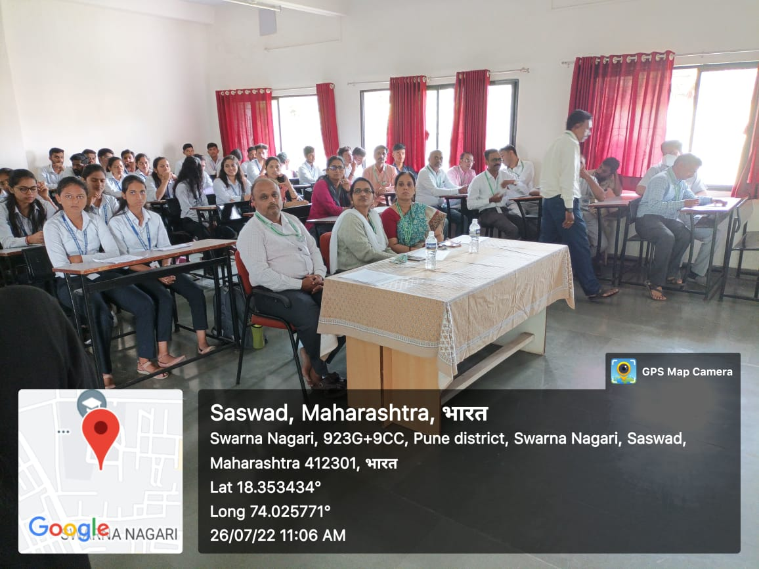
Elocution Competition: Judges, Coordinator and Students

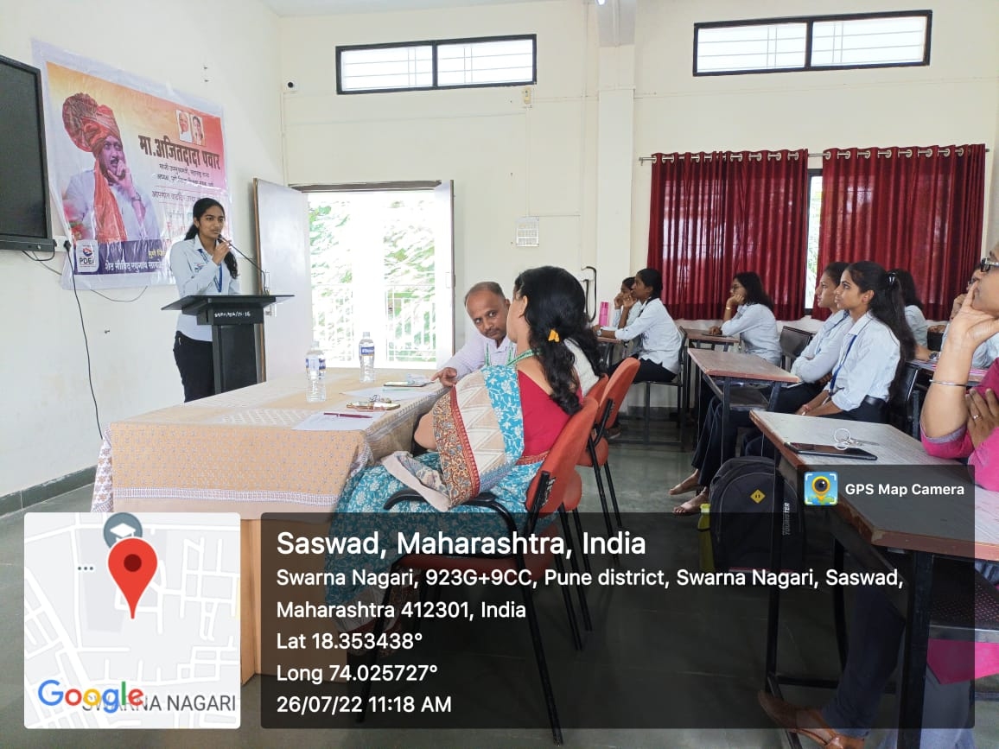

Participant: Ms. Pratiksha Pandit
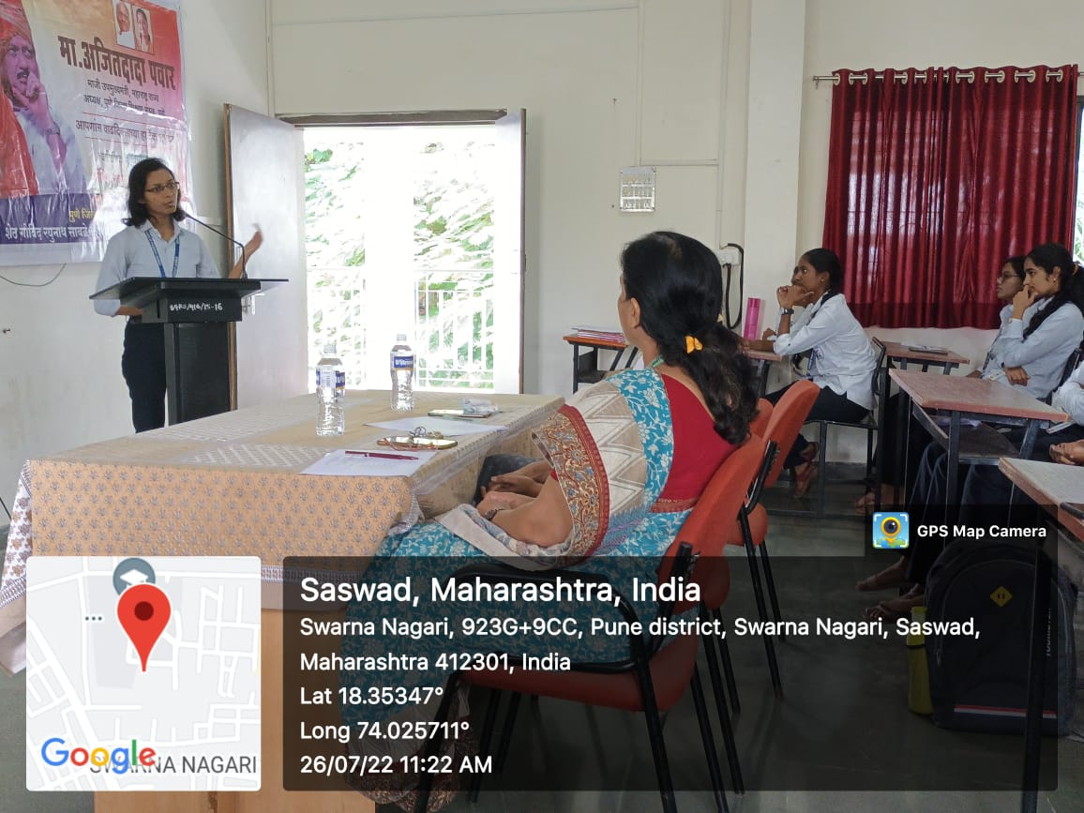

Participant: Ms. Yadav Sakshi

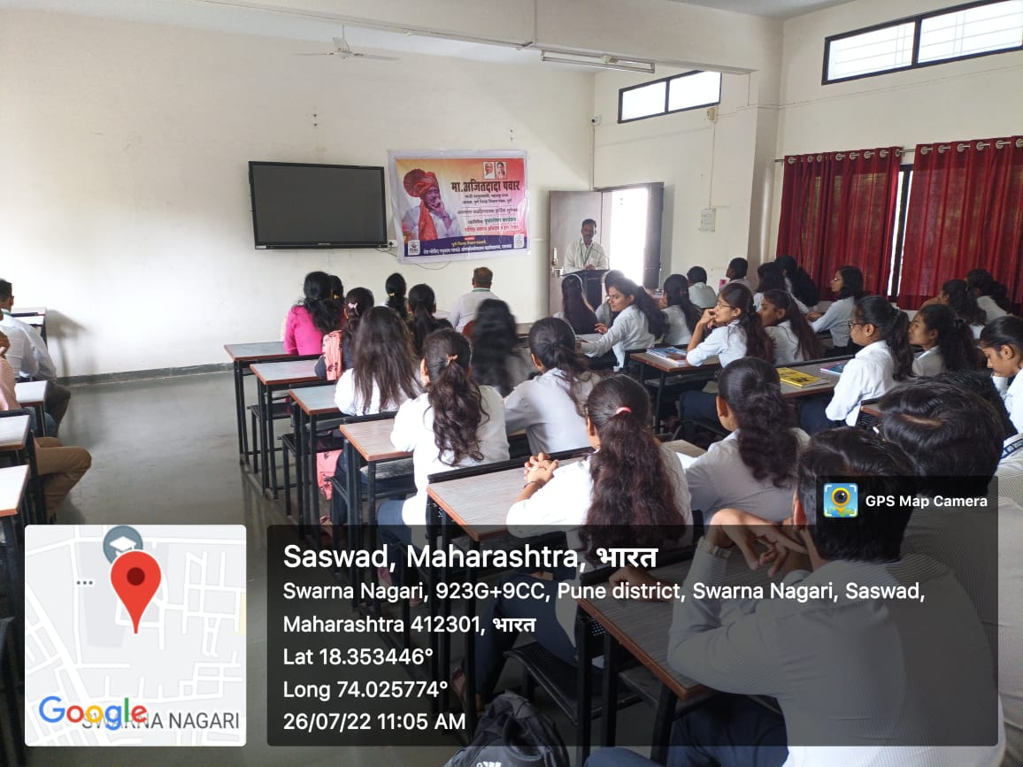
The session was culminated by vote of thanks by Mr. Sanjay Rokade store keeper

